**Task 1**

<html>

<head>

<title>Simple Script</title>

<script>

alert("Hello,World");

</script>

</head>

<body></body>

</html>

**Output:**

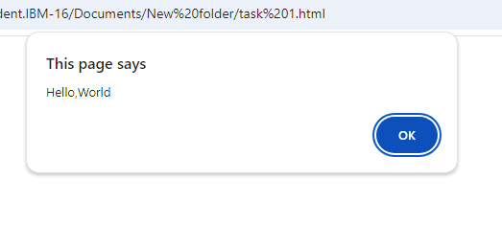

**Task 2**

<html>

<head>

<title>Data Types</title>

<script>

let a=9/0;

console.log("Number:",a);

const b=123456789n;

console.log("Bigint:",b);

let name="Chithra";

console.log("String:",name);

let bol=true;

console.log("Boolean:",bol);

let undefine;

console.log("Undefined:",undefine);

let age=null;

console.log("String:",age);

let i=Symbol("id");

console.log("Symbol:",i);

let user={ name:"Chithra" ,age:20};

console.log("Object:",user);

</script>

</head>

<body></body>

</html>

**Ouput:**

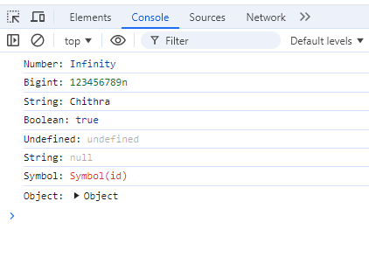

**Task 3**

<html>

<head>

<title>Simple Script</title>

<script>

let a=10,b=2;

console.log("Addition:",a+b);

console.log("Subtraction:",a-b);

console.log("Multiplication:",a*b);

console.log("Division:",a/b);

console.log("Modulus:",a%b);

console.log("Exponent:",a**b);

</script>

</head>

<body></body>

</html>

**Ouput:**

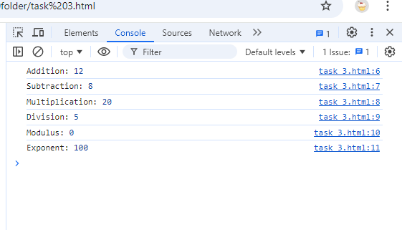

**Task 4**

<html>

<head>

<title>Add Operator</title>

<script>

let a="Hi,";

let b="Chithra";

console.log("Adding two strings:",a+b);

let c="3";

let d="4";

console.log("Adding two number strings:",c+d);

</script>

</head>

<body></body>

</html>

**Ouput:**

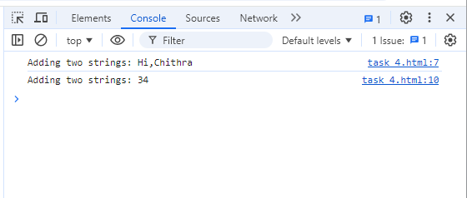

**Task 5**

<html>

<head>

<title>TypeOf Operator</title>

<script>

console.log("TypeOf '209':",typeof 209);

console.log("TypeOf '1245456687665n':",typeof 1245456687665n);

console.log("TypeOf 'alert':",typeof alert);

console.log("TypeOf '123':",typeof "123");

console.log("TypeOf 'false':",typeof false);

console.log("TypeOf 'undefined':",typeof undefined);

console.log("TypeOf 'null':",typeof null);

console.log("TypeOf 'name':",typeof {firstName: "K", lastName: "Chithra"});

console.log("Type of 'Symbolid':", typeof Symbol("id"));

</script>

</head>

<body></body>

</html>

**Ouput:**

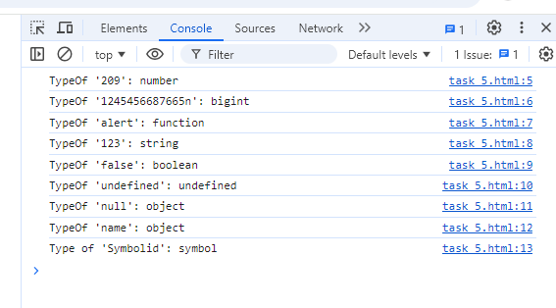

**Task 6**

<html>

<head>

<title>Simple Script</title>

<script>

// Single-line comment

// It is used to comment out a single line of code or write a brief explanation.

console.log("Hello, world!"); //example for single line comment

/*

Below code is a multi-line comment.It is used to write longer comments or explain multiple lines of code in detail.

Multi-line comments can span across multiple lines, making them useful for documentation.*/

console.log("Hi,it is a multiline comment");

</script>

</head>

<body></body>

</html>

**Ouput:**

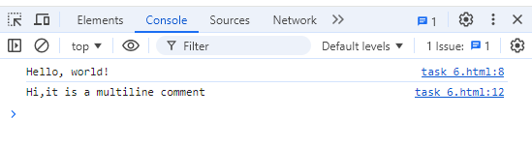

**Task 7**

<html>

<head>

<title>With or Without Semicolon</title>

<script>

//with semicolon

let a=10;

let b=5;

console.log("With Semicolon:",a+b);

//without semicolon

let c=4

let d=2

console.log("Without Semicolon:",c-d)

</script>

</head>

<body></body>

</html>

**Ouput:**

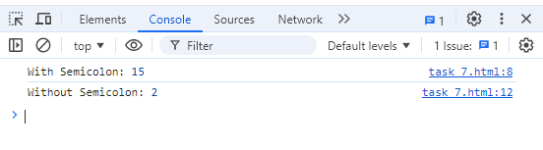

**Task 8**

<html>

<head>

<title> Nested for loop</title>

<script>

for(let i=1;i<=3;i++){

console.log("Outer loop",i);

for(let j=1;j<=2;j++){

console.log("Inner loop",j);

}

}

</script>

</head>

<body></body>

</html>

**Ouput:**

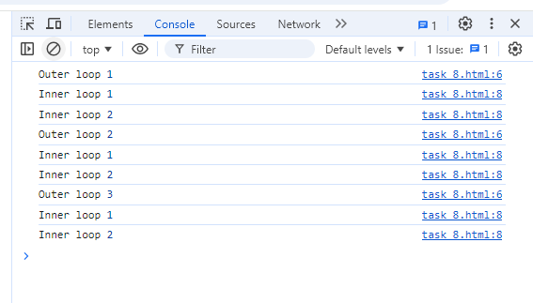

**Task 9**

<html>

<head>

<title>Single line declaration</title>

<script>

let a=209, b=true, name="Chithra", n=null;

console.log("Roll no:",a);

console.log("Name:",name);

console.log("isPresent:",b);

console.log("Null or not:",n);

</script>

</head>

<body></body>

</html>

**Ouput:**

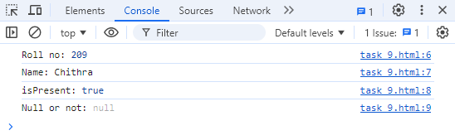

**Task 10**

<html>

<head>

<title>Script tag</title>

<script>

console.log(document.getElementById("script"));

</script>

</head>

<body>

<h1 id="script">Hello, World!</h1>

<script>

console.log(document.getElementById("script").textContent);

</script>

</body>

</html>

**Ouput:**

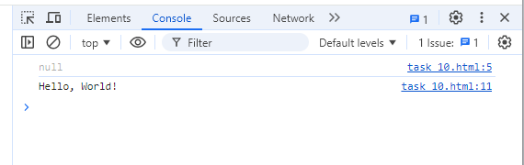

**Task 11**

<html>

<head>

<title>Without Decalartion of variables</title>

<script>

age=20;

console.log("Without declaraing variables without strict:",age);

</script>

</head>

<body></body>

</html>

**Ouput:**

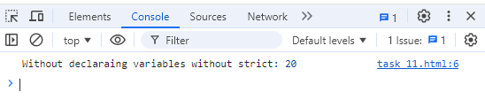

**Task 12**

<html>

<head>

<title>Without Decalartion of variables using strict</title>

<script>

'use strict';

age=20;

console.log("Without declaraing variables using strict:",age);

</script>

</head>

<body></body>

</html>

**Ouput:**

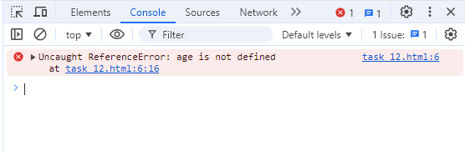

**Task 13**

<html>

<head>

<title>Use strict</title>

<script>

'use strict';

//deleting an variable

let age=20;

delete age;

//deleting an function

function my(){

alert("hello");

}

delete my();

</script>

</head>

<body></body>

</html>

**Output:**

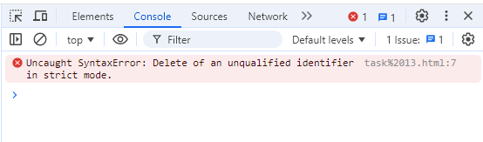

**Task 14**

<html>

<head>

<title>Without Decalartion of variables</title>

<script>

age=20;

console.log("Without declaraing variables:",age);

</script>

</head>

<body></body>

</html>

**Output:**

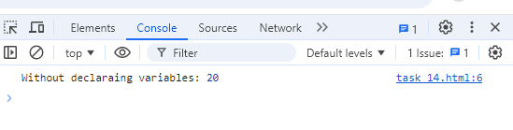

<html>

<head>

<title>Without Decalartion of variables</title>

<script>

'use strict';

age=20;

console.log("Without declaraing variables using strict:",age);

</script>

</head>

<body></body>

</html>

**Output:**

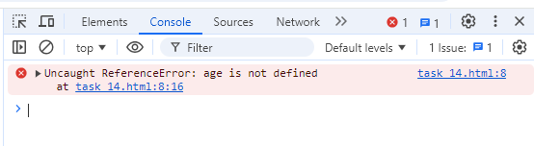

**Task 15**

<html>

<head>

<title>Without Decalartion of variables using strict</title>

<script>

'use strict';

let class=2;

console.log(class);

</script>

</head>

<body></body>

</html>

**Output:**

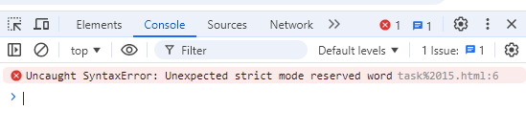

**Task 16**

<html>

<head>

<title> variables Decalartion</title>

<script>

//using let

if(true){

let y=4;

//let y=10;//error

//let cannot be redeclare

console.log("Using let:",y);

}

//console.log(y);//error

//let has access in their block scope level

//using var

if(true){

var v="Chithra";

var v=10;//var can be redeclare

}

console.log("using var:",v);//var has no block scope

//using const

if(true){

const myBirthday='21.04.2005';

console.log("Using const:",myBirthday);//the value is constant it cannot be changed

//const myBirthday='21.05.2005';//error

//redeclaration connot allowed in const

}

</script>

</head>

<body></body>

</html>

**Output:**

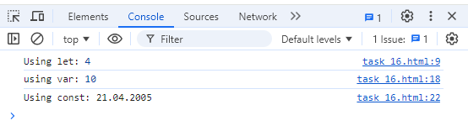

**Task 17**

<html>

<head>

<title>Without Decalartion of variables using strict</title>

<script>

const c=10;

console.log(c);

c=20;

</script>

</head>

<body></body>

</html>

**Output:**

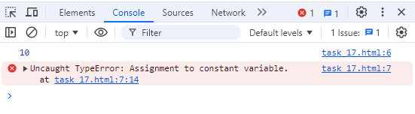

**Task 18**

<html>

<head>

<title> Without Initialization</title>

<script>

let a;

console.log(a);

</script>

</head>

<body></body>

</html>

**Output:**

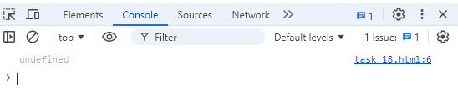

**Task 19**

<html>

<head>

<title>Typeof</title>

<script>

let n=9;

console.log("Typeof 9:",typeof n);

let s="Chithra";

console.log("Typeof 'Chithra':",typeof s);

let b=true;

console.log("Typeof true:",typeof b);

</script>

</head>

<body></body>

</html>

**Output:**

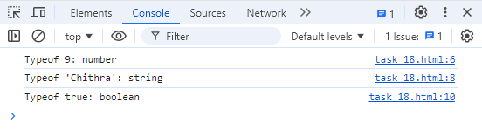

**Task 20**

<html>

<head>

<title>Renaming the variables</title>

<script>

let a=10;

let b=a;

console.log("First variable:",a);

console.log("Second variable:",b);

</script>

</head>

<body></body>

</html>

**Output:**

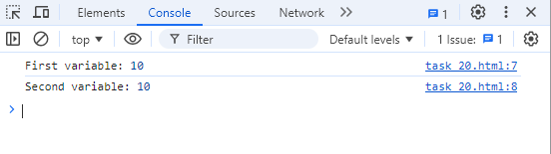

**Task 21**

<html>

<head>

<title>DataTypes</title>

<script>

let s="rose";

console.log(s);

let n=9;

console.log(n);

let b=false;

console.log(b);

let a=null;

console.log(a);

let u;

console.log(u);

let name={

firstName:"K",

lastName:"Chithra"

};

console.log(name);

</script>

</head>

<body></body>

</html>

**Output:**

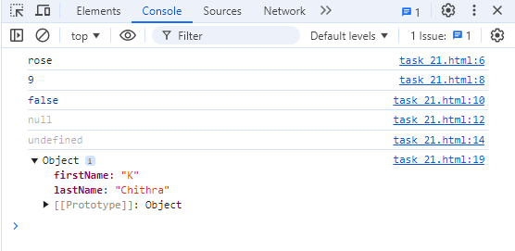

**Task 22**

<html>

<head>

<title> Typeof Datatypes</title>

<script>

let s="rose";

console.log("Typeof 'rose':",typeof s);

let n=9;

console.log("Typeof 9:",typeof n);

let b=false;

console.log("Typeof false:",typeof b);

let a=null;

console.log("Typeof null:",typeof a);

let u;

console.log("Typeof u:",typeof u);

let name={

firstName:"K",

lastName:"Chithra"

};

console.log("Typeof name:",typeof name);

</script>

</head>

<body></body>

</html>

**Output:**

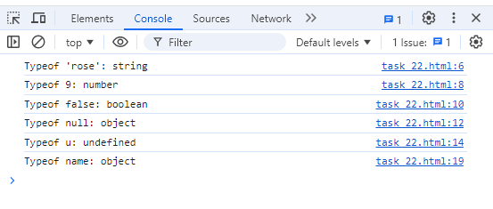

**Task 23**

<html>

<head>

<title>Symbol variable</title>

<script>

let id=Symbol("id");

console.log("Typeof Symbol('id'):",typeof id);

</script>

</head>

<body></body>

</html>

**Output:**

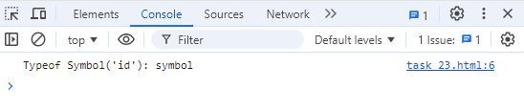

**Task 24**

<html>

<head>

<title>Null variable</title>

<script>

let a=null;

console.log("Typeof null:",typeof a);

</script>

</head>

<body></body>

</html>

**Output:**

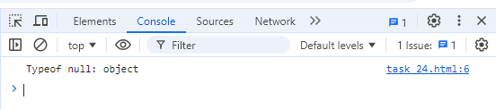

**Task 25**

<html>

<head>

<title>variables Decalartion</title>

<script>

//using var

if(true){

var v="Chithra";

}

console.log("using var:",v);//var has no block scope

//using let

if(true){

let y=4;

}

console.log(y);//error

//let has access in their block scope level

</script>

</head>

<body></body>

</html>

**Output:**

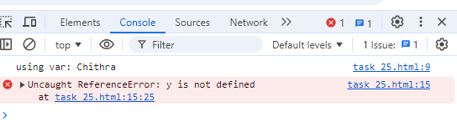

**Task 26**

<html>

<head>

<title>Type Conversion</title>

<script>

//Explicit conversion

let a="21";

let b=Number(a);

console.log("Explicit conversion:",b);

//Implicit conversion

let c="91";

let d=c*1;

console.log("Implicit conversion:",b);

</script>

</head>

<body></body>

</html>

**Output:**

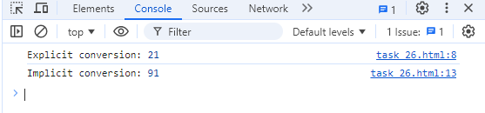

**Task 27**

<html>

<head>

<title>Type Conversion</title>

<script>

'use strict';

//Boolean to string conversion

let a=true;

let b=String(a);

console.log("String conversion:",b);

//String to boolean conversion

let c="";

let d=Boolean(c);

console.log("Boolean conversion:",d);

</script>

</head>

<body></body>

</html>

**Output:**

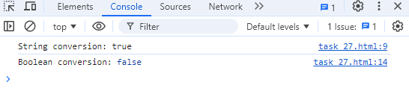

**Task 28**

<html>

<head>

<title>basic arithmetic operators</title>

<script>

let a=8,b=2;

console.log("Addition:",a+b);

console.log("Subtraction:",a-b);

console.log("Multiplication:",a*b);

console.log("Division:",a/b);

console.log("Modulus:",a%b);

console.log("Exponent:",a**b);

</script>

</head>

<body></body>

</html>

**Output:**

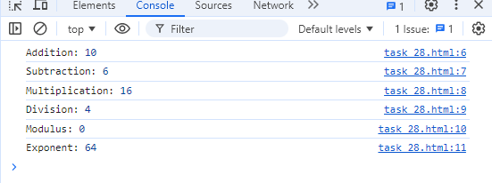

**Task 29**

<html>

<head>

<title>Increement and decreement operators</title>

<script>

let a=4,b=2;

console.log("Post Increement",a++);

console.log("Post decreement:",b--);

console.log("Pre Increement:",++a);

console.log("Pre decreement:",--b);

</script>

</head>

<body></body>

</html>

**Output:**

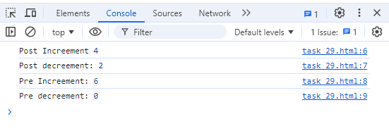

**Task 30**

<html>

<head>

<title>Combination of precendence and multiple operators</title>

<script>

let a=2+3*4;

console.log("Combination of precendence and multiple operators:",a);

</script>

</head>

<body></body>

</html>

**Output:**

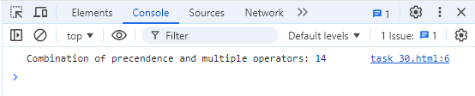

**Task 31**

<html>

<head>

<title>Realtional operators</title>

<script>

let a=8,b=2;

console.log("Greater than:",a>b?a:b);

console.log("Lesser than:",a<b?a:b);

console.log("Greater or equal than:",a>=b?a:b);

console.log("Lesser or equal than:",a<=b?a:b);

</script>

</head>

<body></body>

</html>

**Output:**

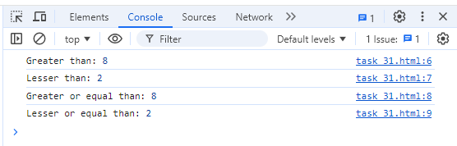

**Task 32**

<html>

<head>

<title>Comparison operators</title>

<script>

//using equality

console.log("String with boolean:","moon"==true);

console.log("String with numbers:","moon"==2);

console.log("Null with undefined:",null==undefined);

//using strict equality

console.log("String with boolean:","moon"===true);

console.log("String with numbers:","moon"===2);

console.log("Null with undefined:",null===undefined);

</script>

</head>

<body></body>

</html>

**Output:**

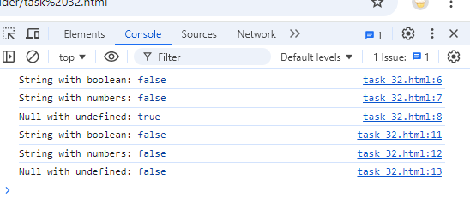

**Task 33**

<html>

<head>

<title>Comparison operators</title>

<script>

console.log("Greater than comparison:","sunflower">"rose");

console.log("Lesser than comparison:","sunflower"<"rose");

console.log("Equality comparison:","sunflower"=="rose");

</script>

</head>

<body></body>

</html>

**Output:**

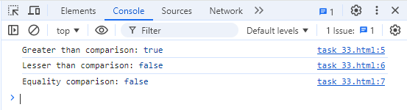

**Task 34**

<html>

<head>

<title>Comparison operators</title>

<script>

console.log("Inequality comparison:","sunflower"!="rose");

console.log("Strict Inequality comparison:","sunflower"!=="rose");

</script>

</head>

<body></body>

</html>

**Output:**

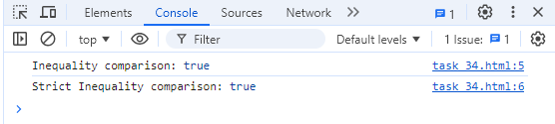

**Task 35**

<html>

<head>

<title>Comparison operators</title>

<script>

//using equality

console.log("Null with undefined:",null==undefined);

//using strict equality

console.log("Null with undefined:",null===undefined);

</script>

</head>

<body></body>

</html>

**Output:**

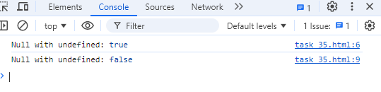

**Task 36**

<html>

<head>

<title>If conditiion</title>

<script>

let num=9;

if(num%2==0){

console.log(num+" is even")

}

else{

console.log(num+" is odd");

}

</script>

</head>

<body></body>

</html>

**Output:**

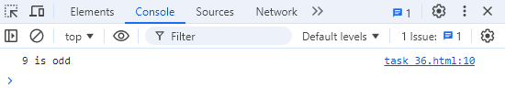

**Task 37**

<html>

<head>

<title>Nested if condition</title>

<script>

let num=-9;

if(num>=0){

if(num>0){

console.log(num+" is positive")

}

else{

console.log(num+" is zero")

}

}

else{

console.log(num+" is negative");

}

</script>

</head>

<body></body>

</html>

**Output:**

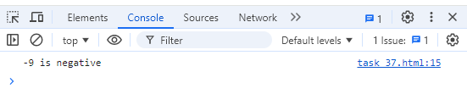

**Task 38**

<html>

<head>

<title>Ternary operators</title>

<script>

let num=4;

console.log(num%2==0?num+" is even":num+" is odd");

</script>

</head>

<body></body>

</html>

**Output:**

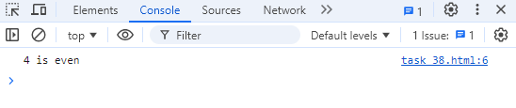

**Task 39**

<html>

<head>

<title>Ternary operators</title>

<script>

let num=4;

console.log(num?num+" is valid":num+" is invalid");

</script>

</head>

<body></body>

</html>

**Output:**

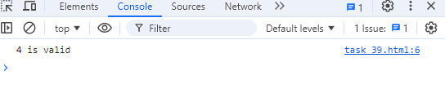

**Task 40**

<html>

<head>

<title>conditional operators</title>

<script>

let a=18;

console.log(a>=18?"Right to vote":"Not right to vote");

let num=4;

console.log(num%2==0?"Even":"Odd");

</script>

</head>

<body></body>

</html>

**Output:**

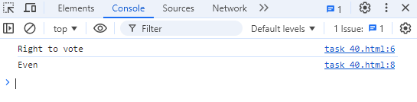

**Task 41**

<html>

<head>

<title>Logical operators</title>

<script>

let a=18,b=true;

console.log(a&&b);

console.log(a||b);

console.log(!(a&&b));

</script>

</head>

<body></body>

</html>

**Output:**

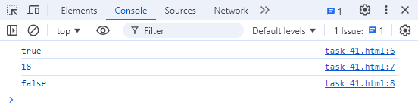

**Task 42**

<html>

<head>

<title>Logical operators</title>

<script>

let a=18,b=4,c=2;

console.log(a>=b && b>=c);

console.log(a<=b || b<=c);

console.log(!(a>=b && b>=c));

</script>

</head>

<body></body>

</html>

**Output:**

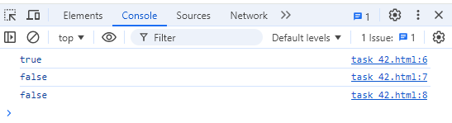

**Task 43**

<html>

<head>

<title>Logical operators</title>

<script>

let b=true;

console.log("Inversion of true using not:",!(b));

</script>

</head>

<body></body>

</html>

**Output:**

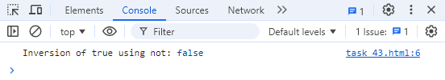

**Task 44**

<html>

<head>

<title>Logical operators</title>

<script>

let a=true,b=3;

console.log("And operator:",a&&(b<5));

console.log("Or operator",a||(b>4));

</script>

</head>

<body></body>

</html>

**Output:**

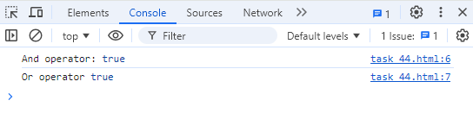

**Task 45**

<html>

<head>

<title>Logical operators</title>

<script>

let a=18,b="apple";

console.log(a&&b);

console.log(a||b);

console.log(!(a&&b));

</script>

</head>

<body></body>

</html>

**Output:**

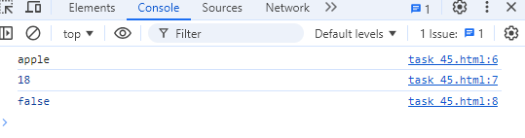

**Task 46**

<html>

<head>

<title> Functions </title>

<script>

let a=4,b=10;

let sum=oddEven(a,b);

console.log("Sum is "+sum);

function oddEven(a,b){

return a+b;

}

</script>

</head>

<body></body>

</html>

**Output:**

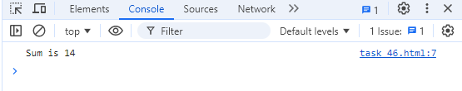

**Task 47**

<html>

<head>

<title> Functions </title>

<script>

let l=4,b=10;

let area=rectangle(l,b);

console.log("Area of rectangle is "+area);

function rectangle(l,b){

return l*b;

}

</script>

</head>

<body></body>

</html>

**Output:**

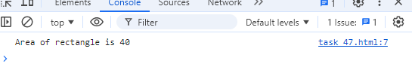

**Task 48**

<html>

<head>

<title> Functions </title>

<script>

fn();

function fn(){

console.log("Hello");

}

</script>

</head>

<body></body>

</html>

**Output:**

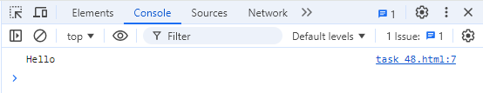

**Task 49**

<html>

<head>

<title>Functions</title>

<script>

let f=fn();

console.log(f);

function fn(){

}

</script>

</head>

<body></body>

</html>

**Output:**

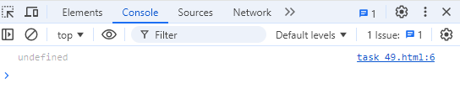

**Task 50**

<html>

<head>

<title>Functions</title>

<script>

function fn(name="",age=""){

console.log(`Hello,my name is ${name} and age is ${age}`)

}

fn();

fn("Chithra",20);

</script>

</head>

<body></body>

</html>

**Output:**

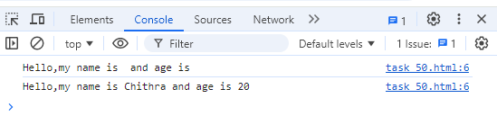

**Task 51**

<html>

<head>

<title>Arrow Functions</title>

<script>

let greet=(name="")=>{

console.log(`Hello,${name} `);

}

greet();

greet("Rose");

greet("Chithra");

</script>

</head>

<body></body>

</html>

**Output:**

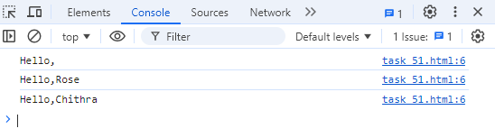

**Task 52**

<html>

<head>

<title>Arrow Functions</title>

<script>

let add=(a,b)=>{

return a+b;

}

let sum=add(5,6);

console.log("Sum of two number is:",sum);

</script>

</head>

<body></body>

</html>

**Output:**

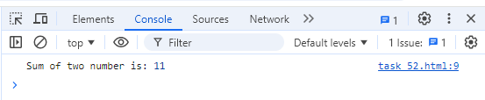

**Task 53**

<html>

<head>

<title>Arrow Functions</title>

<script>

let isEven=(a)=>a%2==0;

let a=6;

console.log(isEven(a));

</script>

</head>

<body></body>

</html>

**Output:**

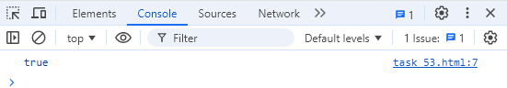

**Task 54**

<html>

<head>

<title>Arrow Functions</title>

<script>

let maxValue=(a,b)=>{

if(a>b) return a;

else return b;

}

let max=maxValue(5,6);

console.log(max+" is largest of two numbers");

</script>

</head>

<body></body>

</html>

**Output:**

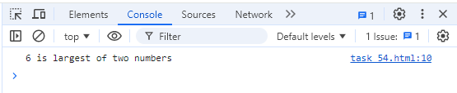

**Task 55**

<html>

<head>

<title>Arrow Functions</title>

<script>

let myObject={

value:10,

multiplyTraditional:function(num){

return this.value*num;

},

multiplyArrow:(num)=>{

return this.value*num;

}

};

console.log("Traditional function:",myObject.multiplyTraditional(5));

console.log("Arrow function:",myObject.multiplyArrow(6));

</script>

</head>

<body></body>

</html>

**Output:**

